24CSI024-DATA STRUCTURES AND ALGORITHMS UNIT 1-INTRODUCTION TO DATA STRUCTURES AND ALGORITHMS Arrays and Array-Based Techniques (Two-Pointer, Sliding Window, Prefix Sums) LAB WORKBOOK-09.07.2026
CATEGORY: EASY
Question 1: Squaring a Sorted Array (Two-Pointer)
Anjali is processing seismic intensity readings stored in a non-decreasing sorted array. The readings can contain negative values (representing reverse-phase wave intensities) as well as positive values. To calculate the kinetic energy of these waves, she needs to square each value and return a new array containing the squares, sorted in non-decreasing order. She must perform this operation in 𝑂(𝑁) time using the two-pointer technique:
- Initialize a left pointer at index 0 and a right pointer at index N - 1.
2. Compare the absolute values of arr[left] and arr[right].
3. Square the larger absolute value and place it at the end of the output array (starting from index N - 1 and moving backwards).
4. Move the corresponding pointer (left inward or right inward) and repeat until the output array is filled.
• The first line of input consists of an integer 𝑁 representing the number of readings.
• The second line of input consists of 𝑁 space-separated integers representing the sorted wave intensities (can contain negative numbers).
• Print a single line of 𝑁 space-separated integers representing the sorted squared values.
• 1≤𝑁≤10000
• −104 ≤𝑎𝑟𝑟[𝑖] ≤ 104
• The input array is sorted in non-decreasing order.
Input 1:
5 -4 -1 0 3 10
Output 1:
0 1 9 16 100
Input 2:
4 -7 -3 2 3
Output 2:
4 9 9 49
Aim:
To write a C program that squares each element of a sorted array containing both negative and positive integers and returns the squared values in sorted order using the Two-Pointer technique.
Pseudocode:
Start

Read N

Create array arr[N]
Create array result[N]

For i = 0 to N - 1
Read arr[i]
End For

left = 0
right = N - 1
index = N - 1

While left <= right

If |arr[left]| > |arr[right]|
result[index] = arr[left] × arr[left]
left = left + 1
Else
result[index] = arr[right] × arr[right]
right = right - 1
End If

index = index - 1

End While

For i = 0 to N - 1
Print result[i]
End For

Stop
Code:
#include <stdio.h>
#include <stdlib.h>

int main()
{
int N;
scanf("%d", &N);

int arr[N], result[N];
for (int i = 0; i < N; i++)
{
scanf("%d", &arr[i]);
}

int left = 0;
int right = N - 1;
int index = N - 1;
while (left <= right)
{
if (abs(arr[left]) > abs(arr[right]))
{
result[index] = arr[left] * arr[left];
left++;
}
else
{
result[index] = arr[right] * arr[right];
right--;
}
index--;
}

for (int i = 0; i < N; i++)
{
printf("%d ", result[i]);
}

return 0;
}
Output Screenshot:
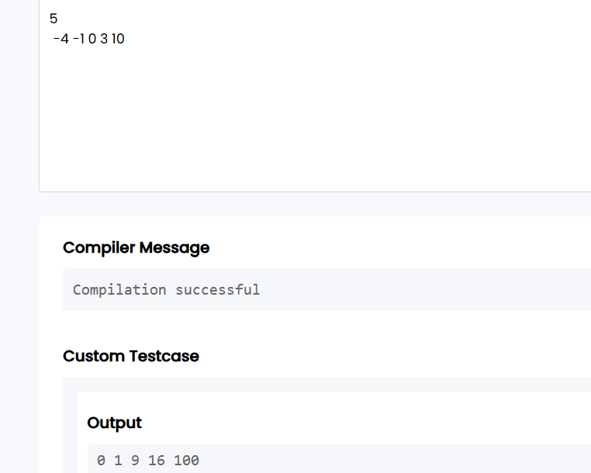
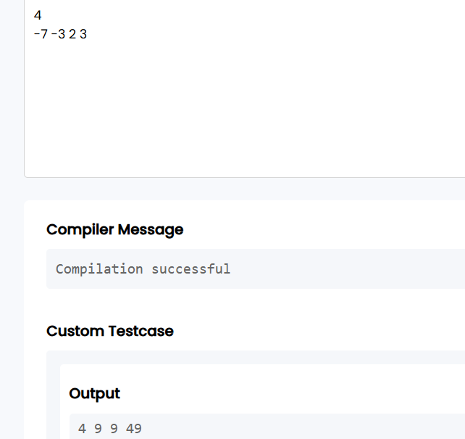
Result:
Thus, the given program was executed successfully and the expected output was obtained.
Question 2: Cumulative Resource Consumption (Prefix Sum)
Kabir is monitoring a data transmission line. He receives a log of data packets transmitted each hour over a period of 𝑁 hours. To generate an hourly usage report, he wants to compute the cumulative running sum of packets transmitted from the start of the log up to each hour. Write a program that takes the hourly logs and outputs the prefix sum array representing the cumulative data volume.
• Let the prefix sum array be P.
• P[0] = arr[0]
• P[i] = P[i-1] + arr[i] for 𝑖 ≥ 1.
• The first line of input consists of an integer 𝑁 representing the number of hours.
Aim:
To write a C program to compute the prefix sum (cumulative running sum) of an array using the Prefix Sum technique.
Pseudocode:
START

Read the number of elements N.

Read the array A.

Create a prefix sum array P of size N.

Set P[0] = A[0].

For i = 1 to N-1
P[i] = P[i-1] + A[i]
End For

Print the prefix sum array P.

STOP
Code:
#include <stdio.h>

int main()
{
int n;
scanf("%d", &n);

int a[n], P[n];

for(int i = 0; i < n; i++)
{
scanf("%d", &a[i]);
}

P[0] = a[0];

for(int i = 1; i < n; i++)
{
P[i] = P[i - 1] + a[i];
}

for(int i = 0; i < n; i++)
{
printf("%d ", P[i]);
}

return 0;
}
Output Screenshots:
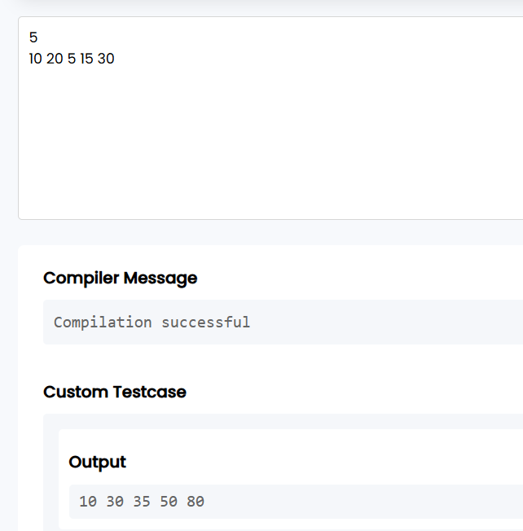
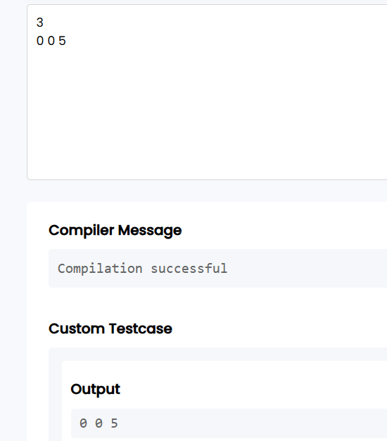
Result:
Thus, the given program was executed successfully and the expected output was obtained.
CATEGORY: MEDIUM
Question 3: Grouping Active Sectors (Fixed-Size Sliding Window)
Sam is working on a flash storage defragmentation algorithm. The sectors of the storage drive are represented by a binary array of size 𝑁, where 1 represents an active data sector and 0 represents an empty sector. To optimize read operations, Sam wants to group all active sectors (1s) together in a contiguous block. He wants to find the minimum number of swaps required to bring all 1s together. This can be solved in 𝑂(𝑁) time using a sliding window:
1. Count the total number of 1s in the array. Let this count be 𝐶. If 𝐶 is 0 or 1, no swaps are needed.
2. Find a contiguous subarray (window) of size 𝐶 that contains the maximum number of 1s.
3. The minimum number of swaps required is then 𝐶 minus the maximum number of 1s found in any window of size 𝐶.
• The first line of input consists of an integer 𝑁 representing the number of sectors.
• The second line of input consists of 𝑁 space-separated binary values (0 or 1).
• Print a single integer representing the minimum swaps required in the format: Min Swaps: X.
• 1≤𝑁≤10000
• arr[i] is either 0 or 1.
Aim:
To write a C program to find the minimum number of swaps required to group all the 1s together in a binary array using the Fixed-Size Sliding Window technique.
Pseudocode:
START

Read N.

Read the binary array.

Count the total number of 1s and store it in C.

If C is 0 or 1
Print "Min Swaps: 0"
Stop

Count the number of 1s in the first window of size C.

Store this count as maxOnes.

Slide the window one element at a time:
Add the new element entering the window.
Remove the element leaving the window.
Update maxOnes if current count is greater.

Minimum Swaps = C - maxOnes.

Print Minimum Swaps.

STOP
Code:
#include <stdio.h>

int main()
{
int n;
scanf("%d", &n);

int arr[n];

for(int i = 0; i < n; i++)
scanf("%d", &arr[i]);

int ones = 0;

for(int i = 0; i < n; i++)
{
if(arr[i] == 1)
ones++;
}

if(ones <= 1)
{
printf("Min Swaps: 0");
return 0;
}

int current = 0;

for(int i = 0; i < ones; i++)
current += arr[i];

int maxOnes = current;

for(int i = ones; i < n; i++)
{
current = current + arr[i] - arr[i - ones];

if(current > maxOnes)
maxOnes = current;
}

printf("Min Swaps: %d", ones - maxOnes);

return 0;
}
Screenshot of the output:
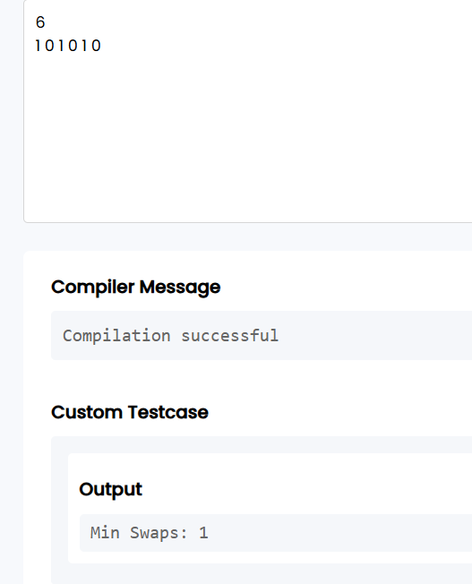
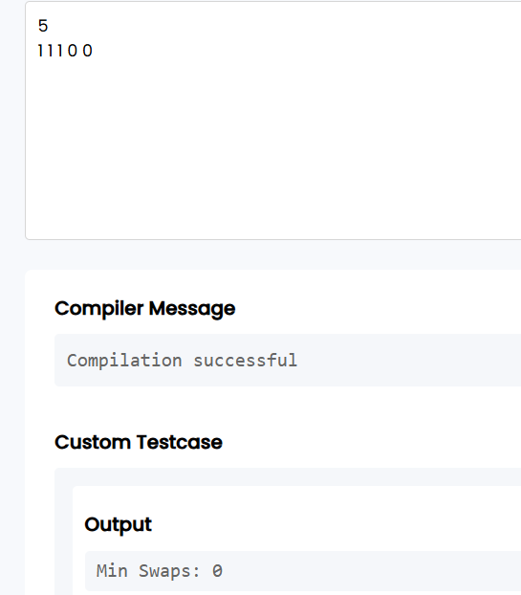
Result:
Thus, the given program was executed successfully and the expected output was obtained.
Question 4: Maximum Task Window Within Budget (Variable-Size Sliding Window)
Riya is scheduling a pipeline of processes on an embedded processor. Each process 𝑖 has a known energy cost arr[i]. The processor has a strict power limit 𝑃 for any contiguous execution sequence. Riya wants to find the maximum number of consecutive tasks she can execute without their combined energy cost exceeding the limit 𝑃. She uses a variable-size sliding window:
1. Maintain a start pointer at index 0 and a running sum of energy current_sum.
2. Iterate an end pointer from 0 to N - 1 and add arr[end] to current_sum.
3. If current_sum exceeds 𝑃,increment start and subtract arr[start] from current_sum until current_sum <= P.
4. Keep track of the maximum window size (end - start + 1) encountered during the process.
• The first line of input consists of two space-separated integers: 𝑁 (the number of tasks) and 𝑃 (the maximum allowed energy consumption).
• The second line of input consists of 𝑁 space-separated positive integers representing the energy costs of the tasks.
• Print a single integer representing the maximum consecutive tasks in the format: Max Length: X.
• 1≤𝑁≤10000
• 1≤𝑎𝑟𝑟[𝑖]≤ 104
• 1≤𝑃≤108
Aim:
To write a C program to find the maximum number of consecutive tasks whose total energy consumption does not exceed the given power limit using the Variable-Size Sliding Window technique.
Pseudocode:
START

Read N and P.

Read the array of task energy costs.

Initialize:
start = 0
current_sum = 0
max_length = 0

For end = 0 to N-1

Add arr[end] to current_sum.

While current_sum > P
Subtract arr[start] from current_sum.
Increment start.
End While

If current window length is greater than max_length
Update max_length.
End If

End For

Print max_length.

STOP
Code:
#include <stdio.h>

int main()
{
int n, p;
scanf("%d%d", &n, &p);

int arr[n];

for(int i = 0; i < n; i++)
scanf("%d", &arr[i]);

int start = 0;
int current_sum = 0;
int max_length = 0;

for(int end = 0; end < n; end++)
{
current_sum += arr[end];

while(current_sum > p)
{
current_sum -= arr[start];
start++;
}

if(end - start + 1 > max_length)
max_length = end - start + 1;
}

printf("Max Length: %d", max_length);

return 0;
}
Screenshot of the output:
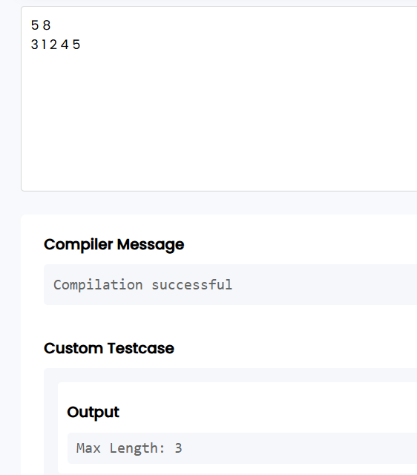

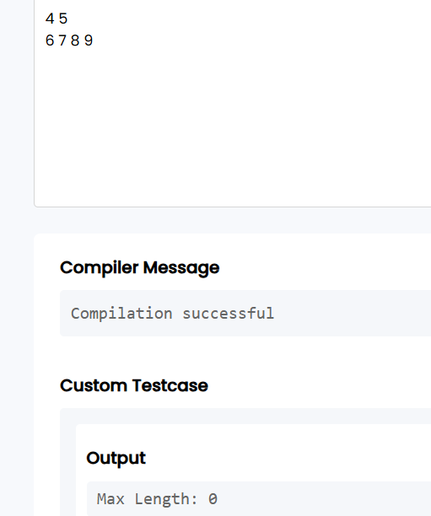
Result:
Thus, the given program was executed successfully and the expected output was obtained.
Question 5: Sliding Window Maximum Peak (Monotonic Window Queue)
CATEGORY: HARD
Rohan is building a real-time graphics rendering system. The system receives a sequence of frame rendering times. To smooth out frame drops, Rohan must calculate the peak (maximum) rendering time in every sliding window of 𝐾 consecutive frames. To achieve an optimal 𝑂(𝑁) runtime, Rohan uses a monotonic double-ended queue (deque) to store indices of elements in the sliding window:
1. As the window slides from left to right, maintain the deque such that indices of elements are stored in decreasing order of their corresponding values.
2. For each element arr[i]:
o Remove indices from the back of the deque if their corresponding values are less than or equal to the current element arr[i] (they can no longer be the maximum).
o Insert the current index i at the back of the deque.
o Remove the index from the front of the deque if it falls outside the bounds of the current sliding window (i.e., if the index is less than i - K + 1)
- For every step where the window is fully formed (when i >= K - 1), the element at the index stored at the front of the deque is the maximum for that window.
Note: Since standard C does not have a built-in deque, you can implement a basic deque using a pre allocated array of size 𝑁 with front and rear pointer indices.
• The first line of input consists of two space-separated integers: 𝑁 (the total number of frames) and 𝐾 (the sliding window size).
• The second line of input consists of 𝑁 space-separated integers representing the frame rendering times.
• Print a single line of space-separated integers representing the maximum value for each sliding window of size 𝐾.
• 1≤𝐾≤𝑁≤10000
• −105 ≤𝑎𝑟𝑟[𝑖] ≤ 105
Input 1:
8 3 1 3 -1 -3 5 3 6 7
Output 1:
3 3 5 5 6 7
Input 2:
4 2 4 3 2 1
Output 2:
4 3 2
Aim:
To write a C program to find the maximum element in every sliding window of size K using a monotonic deque for an O(N) time complexity.
Pseudocode:
START

Read N and K.

Read the array.

Create an array to act as a deque.

Initialize front and rear.

For each index i from 0 to N-1

Remove indices from the front if they are outside
the current window.

Remove indices from the rear while the current
element is greater than or equal to the elements
represented by those indices.

Insert the current index at the rear.

If the first window is formed
Print the element whose index is at the
front of the deque.
End If

End For

STOP
Code:
#include <stdio.h>

int main()
{
int N, K;
scanf("%d %d", &N, &K);

int arr[10000];
int deque[10000];

int front = 0, rear = -1;

for (int i = 0; i < N; i++)
scanf("%d", &arr[i]);

for (int i = 0; i < N; i++)
{
while (front <= rear && arr[deque[rear]] <= arr[i])
rear--;

deque[++rear] = i;

if (deque[front] < i - K + 1)
front++;

if (i >= K - 1)
printf("%d ", arr[deque[front]]);
}

return 0;
}

Screenshot of the output:
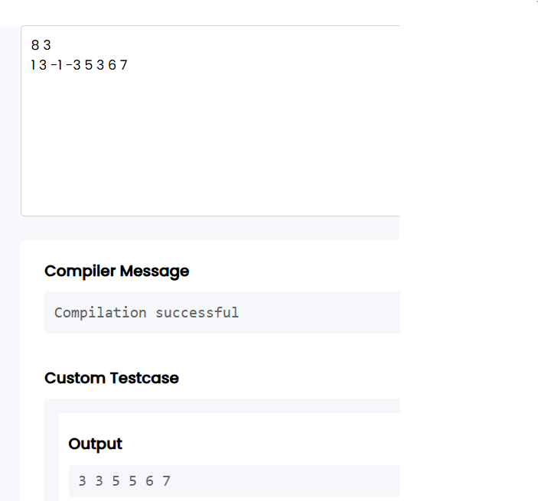
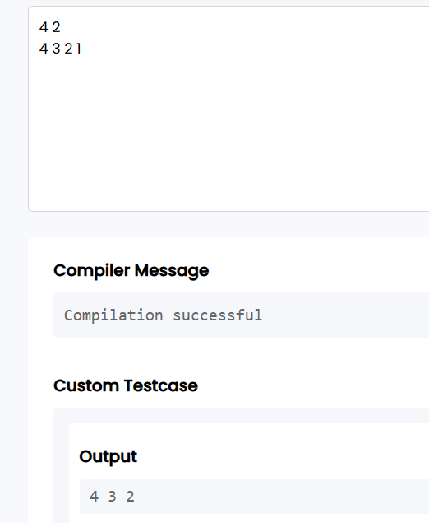
Result:
Thus, the given program was executed successfully and the expected output was obtained.
VIVA QUESTIONS:
1. Why is a List or Queue an ADT while an Array is a data structure? How is this separation maintained in C?
Answer:
An ADT defines what operations can be performed, while a data structure defines how the data is stored. In C, we separate them by providing function prototypes (interface) in a header file (.h) and implementing them using arrays in a source file (.c).

2. Why does the two-pointer technique never miss the correct pair in a sorted array?
Answer:
Since the array is sorted, increasing the left pointer increases the sum, and decreasing the right pointer decreases the sum. Therefore, no possible pair is skipped, and backtracking is unnecessary.

3. Which is better for finding a target sum in an unsorted array: sorting + two pointers or a hash map?
Answer:
- Sorting + Two Pointers: O(n log n) time, O(1) extra space.
- Hash Map: O(n) average time, O(n) extra space.
For memory-constrained embedded systems, sorting is usually preferred because it uses less memory.

4. Why does the variable-size sliding window fail when the array contains negative numbers?
Answer:
Negative numbers can decrease the sum unexpectedly. Expanding or shrinking the window no longer changes the sum predictably, so the algorithm may miss valid subarrays.

5. What is the cost of updating one element in a prefix sum array?
Answer:
Updating one element requires updating all following prefix sums, so the time complexity is O(n).

6. What is passed when an array is sent to a C function? Why can't sizeof() find its size inside the function?
Answer:
Only the base address (pointer) of the array is passed. Inside the function, sizeof(array) returns the size of the pointer, not the actual array.

7. What problem can occur while building a prefix sum array for large data? How is it avoided?
Answer:
Integer overflow can occur when the cumulative sum becomes too large. Use a larger data type such as long long to avoid overflow.

8. Give an example of fixed-size and variable-size sliding windows in a heart-rate monitor.
Answer:
- Fixed-size: Average heart rate over the last 10 seconds.
- Variable-size: Find the shortest time interval where the heart rate exceeds a threshold.

9. Why can an index be removed from the back of a monotonic deque in Sliding Window Maximum?
Answer:
If the new element is greater than or equal to the old one, the old element can never become the maximum in future windows, so it is discarded.

10. How is a 2D prefix sum used for image processing? What does each cell represent?
Answer:
A 2D prefix sum stores the sum of all elements from the top-left corner (0,0) to the current cell (i,j). This allows any sub-rectangle sum to be calculated in O(1) time.
GITHUB REPO LINK: https://github.com/sudarshinib2405-sys/24CSI024-25BAD116/tree/main

